

**Ministry of Water Resources, River Development and Ganga Rejuvenation**

**#MWR5**

**Awareness on Arsenic contamination in ground water**

|  |  |  |  |
| --- | --- | --- | --- |
| **Idea / Approach Details** | | | |
| **Ministry:** | Water Resources, River Development and Ganga Rejuvenation | **Problem Code:** | #MWR5 |
| **Problem Statement:** | Awareness on Arsenic contamination in ground water | **AICTE Institute ID:** | 1-1366332831 |
| **Team Leader:** | V. Kethareswaran | | |

**Idea: Creation of hybrid application – National Water Quality Portal**

The idea is to develop a website as well as a mobile application to create awareness about arsenic contamination in ground water with the available data provided by the central ground water board. Also the grievances met out in this regard & various schemes initiated by central ground water board in providing quality drinking water will be advertised.

**Solution / Prototype:**

* Central Ground Water Board (CGWB) is monitoring groundwater quality annually as well as in special studies for arsenic contamination.
* Public to be made aware of the effects upon using arsenic contaminated water for drinking and irrigation purposes.
* Thus we need to develop a website as well as a mobile application to create awareness about arsenic contamination in ground water.
* The website will host a login for every CGWB office situated at district headquarters of various states wherein the accessed water quality data can be entered for public display.
* Also a grievance portal for public to report any adverse effects due to groundwater contamination will be available.
* Actions initiated against grievances will be displayed in the webpage/app.
* Details on arsenic contamination such as effects, causes, symptoms, precautionary measures will be made aware via the web page/app.
* Various schemes initiated by central ground water board in providing quality drinking water will be advertised.
* Nationwide data can be accessed in open by the public.
* A click on the map specific location will display the link about that district where the recorded data can be viewed.

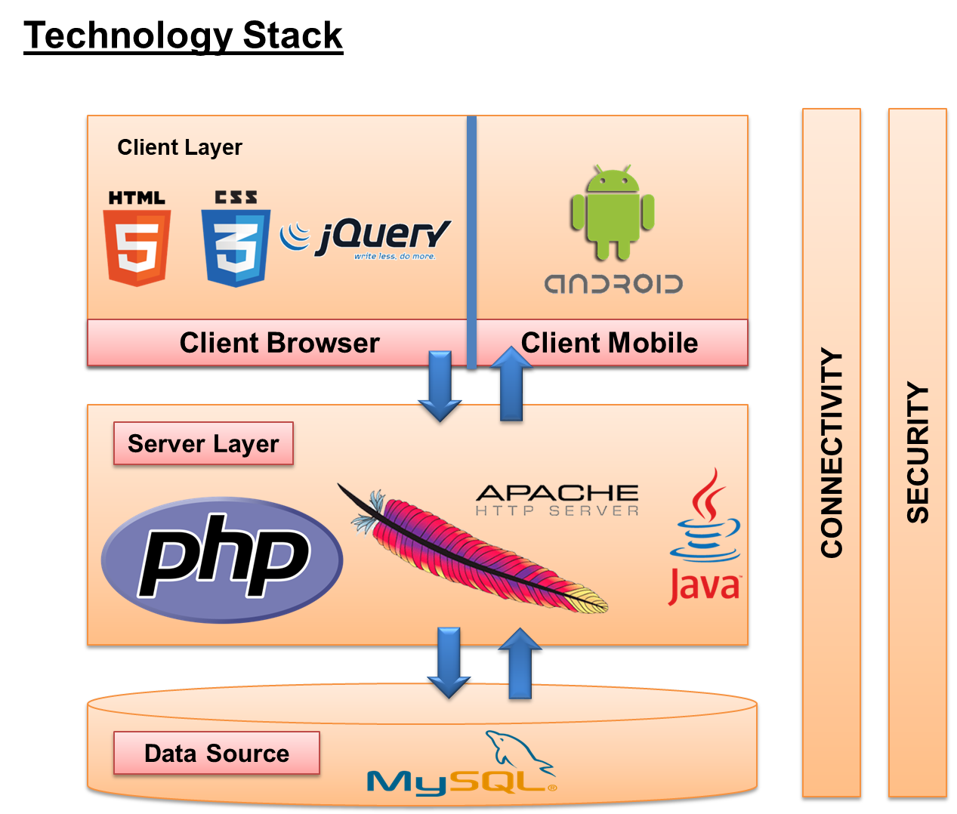

USE CASE DIAGRAM:

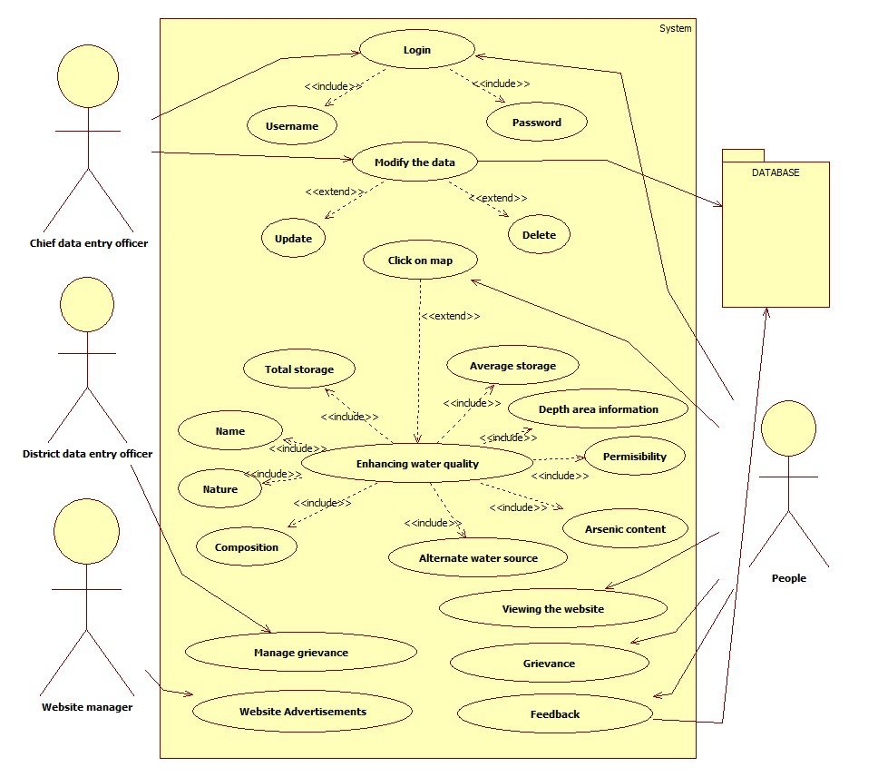

Dependencies:

Data Provided upon Annual & Specific Surveys of Arsenic Contamination in Ground Water by Central Ground Water Board (CGWB).

UX / UI (Sample):

